# How to make a Persistent Volume’s reclaim policy as retain.

This is needed in case App team would like to retain their Persistent Volume, even if they delete their PVC. One of the [use case](https://www.flowdock.com/app/hpe/hpeit-ecp-hub/threads/kL2eNJBGWBozA9dFrYYFLhifDQ6).

1. Describe the pod that has the PV mounted, which needs the update in Reclaim policy and get the PVC name

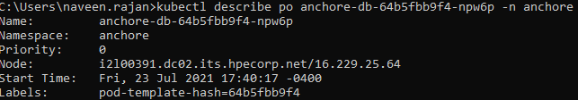

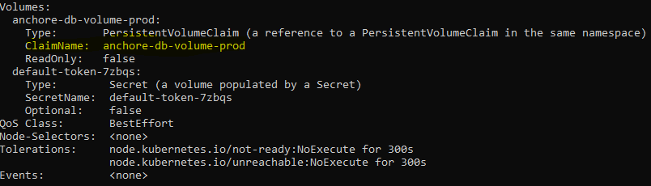

1. Describe PVC to get the Volume name

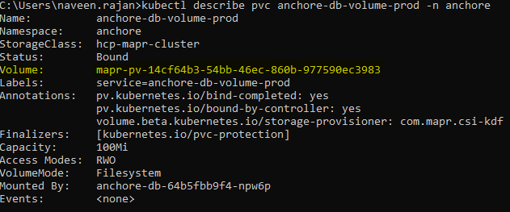

1. Edit the PV to update the Reclaim policy to ‘Retain’ (case-sensitive)-



Edit the field as shown, save and close it-

